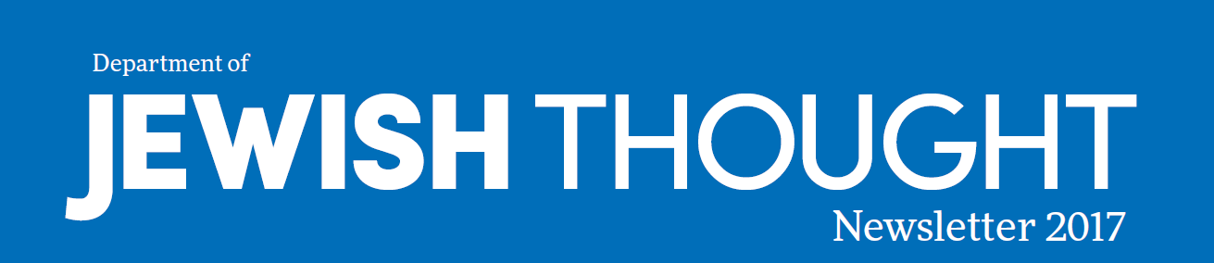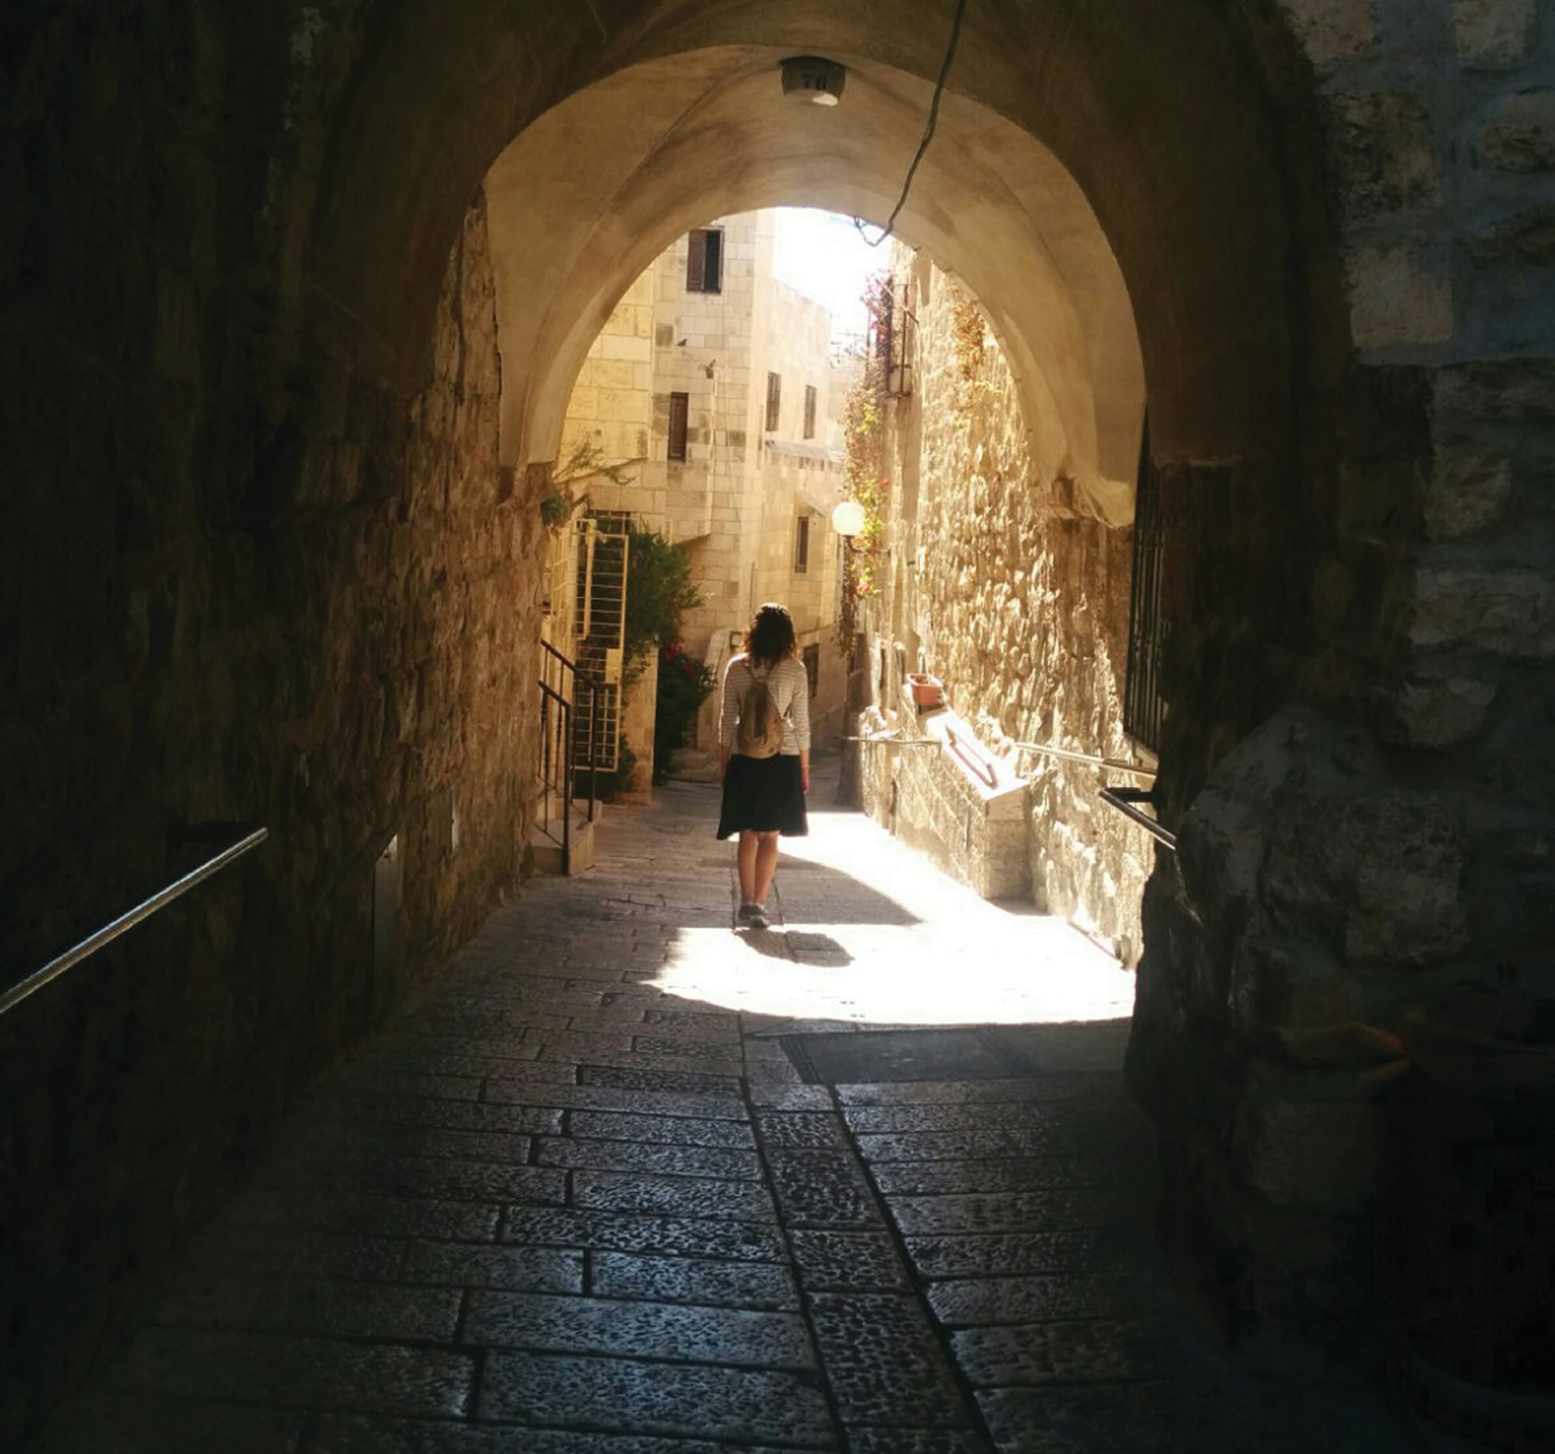
Newsletter 2017

Spotlight
Dr. Harold and Arlyne Levy

p.7

The Jewish Quarter in the Old City of Jerusalem

TABLE OF CONTENTS
About the Department
The Department of Jewish Thought was created to serve as a multidisciplinary research and academic department focused on teaching and scholarship related to the contributions of the Jewish tradition in the development of Western civilization. Our mission is to foster knowledge, inquiry and scholarly
excellence to better understand Judaism, along with its contributions to a deeper understanding of current agendas and the social challenges of humanity at large.
Throughout its long and diverse history, a central and unifying feature of Judaism is its emphasis on ethics, on biblical and rabbinic teachings of morality, and the prophetic call to justice. Nourished by the
enormous spiritual, intellectual and cultural contributions of a long and productive history, and of a pluralist tradition which remains alive and vibrant in today’s world, the Department of Jewish Thought is especially attentive to the grand tradition of Western philosophy and to contemporary literary theory and criticism.
We invite you to follow our growth as we strive to excel in teaching and scholarship.

STAFF
EDITORS: Gina Cali-Misterkiewicz, Elin Hawkinson, Michele Parente

In this Issue:
3 ››
3-4 ››

4 ››

5 ››
6 ››

7 ››

On the cover:

Message from the Chair
› Sergey Dolgopolski

Our Faculty
› Richard Cohen
› Sergey Dolgopolski
› Alex Green
› Noam Pines
› Marla Segol

Features
› New Biblical Hebrew Course
› Book Publications
› Update: New MA in Jewish Thought
Fall 2017 | Lectures and Symposiums Features
› A 5th Successful Summer
Seminar: “Emmanuel Levinas on Morality, Justice and the Political”
› Recent Lectures and Symposiums

Alumni and Friends
› Alumni Updates
› Spotlight on Dr. Harold and Arlyne Levy
› 2017 Fellowships, Scholarships and Awards

CREATIVE DIRECTOR: Renee Ruffino
DESIGNER: Pierce Strudler
When the department was in need of new promotional materials, Chair Sergey Dolgopolski asked his daughter, Elen-Sarrah Dolgopolskaia, who was studying in Israel, to snap some photos. She captured this ethereal image of her friend, Tamar Even-Hen, strolling through the Jewish Quarter in the Old City of Jerusalem.
Photo: Elen-Sarrah Dolgopolskaia

SUPPORT

We are grateful to our many supporters. Your generosity – at every level – has been the driving force behind the growth and development of this department.

HOW TO SUPPORT THE DEPARTMENT OF JEWISH THOUGHT

http://www.buffalo.edu/giving/jewishthought 716-645-0841
College of Arts and Sciences
Office of Philanthropy and Alumni Engagement 921 Kimball Tower

MESSAGE FROM THE CHAIR | SERGEY DOLGOPOLSKI

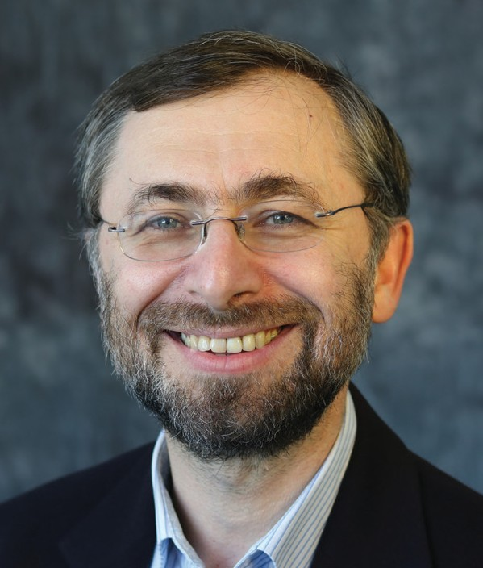
ear students, col- leagues and friends of the Department
D
of Jewish Thought and the greater Buffalo community,

As the department enters its second full academic year, it is both a pleasure and a privi- lege to share with you some quick facts about the first year, and highlights of the year to come.

In the 2016-17 academic year, our department served more than 300 un- dergraduate students, including current and prospective majors and minors. This tremendous increase is leading us to ex- plore possibilities for opening our classes to even more students.

Our faculty recently published two new research monographs, and another three are at different stages of publication: either forthcoming in spring 2018, under contract or undergoing review by the press.

“It is clear to me that all we have accomplished was only possible
with your help.”
One international conference, one NEH-supported summer school and a
series of five community lectures further elevated our department’s involvement with students, colleagues and the com- munity. More academic conferences and community talks are in the works for this year’s programming.
It is clear to me that all we have accom- plished was only possible with your help. Our future development and success continue to depend on that support. Please read on, and we invite you to visit our web- site at http://jewishthought.buffalo.edu to learn more about our plans, and how you can contribute to our goals by attending/ sponsoring new and existing events or programs.

OUR FACULTY
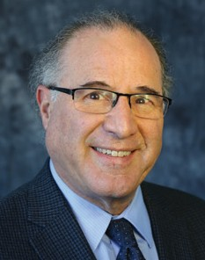
Professor Richard Cohen spent spring 2017 as a visiting research professor in the University of Rome – La Sapienza’s Department of Political Science, where he
gave a series of lectures on modern political philosophy. He also received an NEH grant to support a Summer Seminar for University and College Teachers at UB July 17-21, 2017 (p. 6). Additionally, he published articles on “Ju- daism and Philosophy” in Common Ground Journal (V.12, N.2. Fall 2016) and “Lukacs and Levinas: Totality and Infinity – Phenomenol- ogy Hegelian and Husserlian, and Kantian Ethics” in the edited volume “Political Phenomenology” (ed. Lester Embree and Hwa Yol Jung, Springer International Publishing,
Switzerland, 2016). Professor Cohen will go on research leave again next spring to continue work on a new book on political
philosophy; this leave is partially supported by the UB Humanities Institute.

Professor Sergey Dolgopolski’s new monograph, Other Others: The Political after the Talmud, was approved for publication with Fordham University Press and
is forthcoming in spring 2018. He also published four articles, including “Tosafot Gornish Post-Kant: The Talmud as Political Thought” in Talmudic Transgressions,
the Daniel Boyarin Festschrift. Professor Dolgopolski presented three research papers: 1) “Talmud and Philosophy,” a public lecture and three-days intensive seminar at the Institute for Jewish Studies,
University of Antwerp, Belgium; 2) “Talmud and Philosophy,” an invited lecture and
text-study session for the Center for Jewish Philosophy at the Society for Phenomenology and Existential Philosophy National Conference at Salt Lake City; and 3) “Are Jews Melancholic Acedia in Rabbinic (In)action,”
at the “Jews and Melancholia” International Symposium, University at Buffalo. Professor Dolgopolski continues to serve as the chair of the department.

Yours,
Sergey Dolgopolski

Jewish Thought 2017 3

OUR FACULTY

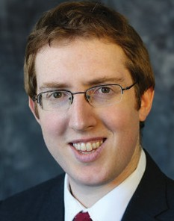
Professor Alex Green’s recently published book, The Virtue Ethics of Levi Gersonides, has been sub- mitted for three possible awards. He continues
his research on Gersonides with a paper entitled “Gersonides on Job’s Ethical Error,” slated for presentation in January at the Society of Jewish Ethics, and he has begun working with David Horwitz, PhD, of Yeshi- va University on an English translation of Gersonides’ commentary on Genesis, enti- tled “Gersonides’ Lessons (To’alot) on Gen- esis.” Professor Green has also completed the manuscript of his next book focusing on the medieval Jewish philosopher and biblical exegete Joseph Ibn Kaspi (1279- 1340) entitled “Joseph Ibn Kaspi and the Meaning of History: The Bible as Historical Wisdom.” Along with his work organizing the community lecture series with the BJE of Buffalo, Professor Green has accepted the position of Director of Undergraduate Studies and has begun preparing for ways to grow the department’s undergraduate base.
Professor Noam Pines’ first book, The Infrahuman: Animality in Modern Jewish Literature, for which he was awarded UB’s Julian Park Publication Fund, will be
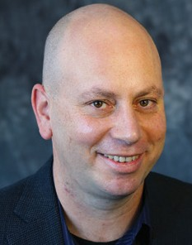
published by SUNY University Press in 2018. He published “The Love of a Dog: Mel- ancholia in David Vogel’s Before the Dark Gate,” in Jewish Studies Quarterly (v. 23, N. 2, 2016), while another article, “Suffering Jews and Animals in S. Y. Abramovitsh’s Di Kliatshe” is forthcoming in Jewish Social Studies. Professor Pines also serves as editor (along with Vivian Liska) of a special issue on “Jews and Melancholia” in the Journal of Jewish Identities, to which he will contribute an article entitled “The Portrait of the Jew as a Saturnian Cannibal.” His critical introduction and translation of several chapters from Hans Ulrich Gum- brecht’s “The Broad Present” have been approved for publication in 2018 in Ot: A Journal of Literary Criticism and Theory (Tel Aviv University), for the first time in
Hebrew. Professor Pines’ second book man- uscript, “Children of Saturn: Jews in the Constellation of Melancholia,” is currently under review with Indiana University Press. He was recently appointed literary editor of Higher Hebrew Education.
Professor Marla Segol has been hard at work on two major projects: 1) finishing a book entitled “Tracing the Body Divine;” and 2) beginning another entitled
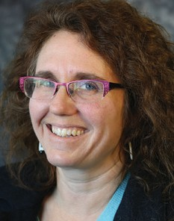
“Sacred Sexuality in North America: Roots and Shoots,” for which she received a grant. An article, “Hebrew Astrology Before and After Islam,” was published in January in Journal of Magic, Ritual, and Witchcraft. A second article, “Feeling and Wisdom in the Sefer Bahir” is currently under editorial review for a special “Mysticisms” issue of English Language Notes, to be published in winter 2018. A third article, “Devotional Embryologies,” was presented in April by special invitation at the Mediterranean Seminar, University of Colorado at Boul- der. Additionally, Professor Segol delivered papers at four academic conferences, and served as Division Chair for the Jewish Mysticism section at the Association for Jewish Studies, as the Vice President of Societas Magica, as a board member for the Western Esotericism Section at the Amer- ican Academy of Religion and as the Chair for the Committee on Academic Freedoms and Responsibilities at UB. She is stepping down after completing her fifth year as Director of Undergraduate Studies.

Book Publications
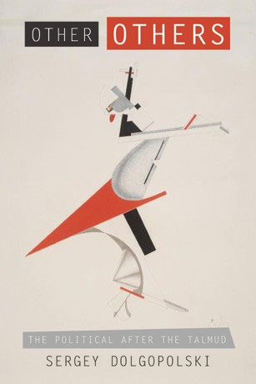
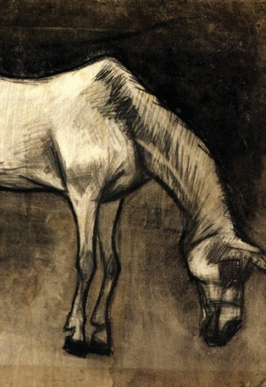
Professor Sergey Dolgopolski’s new monograph, Other Others: The Political after the Talmud, will be published with Fordham University Press in May 2018.
New Biblical Hebrew Course Open to Community
In addition to the department’s regular courses in modern conversational Hebrew, a new course in Biblical Hebrew is planned for spring 2018. Through the translation of Biblical passages into English, and the analysis of text, this 15-week, Monday evening course will serve as an introduction to the unique vocabulary and structure of Biblical Hebrew.
The course is offered in English, with no pre-requisites, Community members over 65 can register for this course for free through the senior audit program. Registration begins mid-October.
For further information, please contact: jewish-thought@buffalo.edu

4

Professor Noam Pines’ first monograph, Infrahuman: Animality in Modern Jewish Literature will be published with SUNY University Press in August 2018.

Update: New MA in Jewish Thought
The new MA in Jewish Thought is currently under review and we will provide more information as the process progresses.

2017 Jewish Thought

FALL 2017 | LECTURES AND SYMPOSIUMS
David Blitzer Lecture Series – "The Future of Jewish Tradition: What Should Jewish Thought Be?” OCT. 19, 2017 AT 7PM

Traditions always respond to new challenges, and on that depends their future. At a time when technological thinking facilitates a tacit but dangerous move from democracy to technocracy, turning to intellectual resources of Biblical Ethics and its Jewish tradition as one of the three pillars of Western humanity (along with Greek philosophy and Roman law) becomes vital. It is about reclaiming the role of Jewish tradition as not only and not primarily promoting technological advancement, but also and more importantly developing new ways of thinking in the face of each new challenge and each new responsibility that greets us.
Two of the most intellectually powerful and creative leading scholars in Jewish Thought, professors Martin Kavka and David Metzger, will present talks, followed by round-table discussion for faculty, graduate students and community members.
The event is open to the public. In consideration of space and refreshment needs, and to receive further information and updates on the event, please RSVP to jewish-thought@buffalo.edu or 716-645-3695.
“Cosmopolitanism versus Globalization” Symposium
OCT. 23, 2017 AT 10AM-6PM AND OCT. 24, 2017 AT 10AM-1PM

There is an increasingly obvious conflict between the culture of a genuine cosmopolitanism, originating in the qualitative creativity of local contexts, yet in communication with a worldwide Republic of Letters, and globalization, with its quanti- tative anti-culture of commodification, cost-benefit and publicity motivated by monetary profiteering. The aim of this two- day symposium is to investigate, clarify and weigh the claims regarding an opposition between the spiritual heritage and “aura” of specific cultural cosmopolitanism and abstract commercial globalization: what Guy Debord called “the specta- cle.” What can be done to resist the sedative complacency and compliance of global capitalist ideology and entertainment, which, as Herbert Marcuse put it, “delivers the goods?”
Participants
-Richard A. Cohen, Department of Jewish Thought, UB (organizer)
-Joseph Conte, Department of English, UB
-Sergey Dolgopolski, Department of Jewish Thought, UB
-Tito Marci, Department of Political Science, University of Rome - La Sapienza, Rome, Italy
-Deborah Reed-Danahay, Department of Anthropology, UB
-Luca Scuccimarra, Department of Political Science, University of Rome - La Sapienza, Rome, Italy The event will take place at the University of Buffalo and is open to the public.

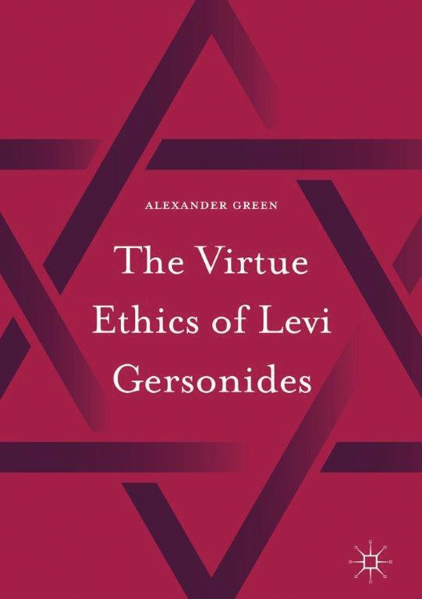
Join Professor Alex Green for an intriguing discussion of his new book, The Virtue Ethics of Levi Gersonides, followed by light refreshments.
The event will take place in the Samuel Freidman Library and is open to the public. In consideration of space and refreshment needs, and to receive further information and updates on the event, please RSVP to jewish-thought@buffalo.edu.

Look for the most current information on these events, as well as spring 2018 events, at:
http://jewishthought.buffalo.edu/events
Book Launch Party: “The Virtue Ethics of Levi Gersonides”
NOV. 1, 2017 AT 7PM

Jewish Thought 2017 5

FEATURES

A 5th Successful Summer Seminar: “Emmanuel Levinas on Morality, Justice and the Political”

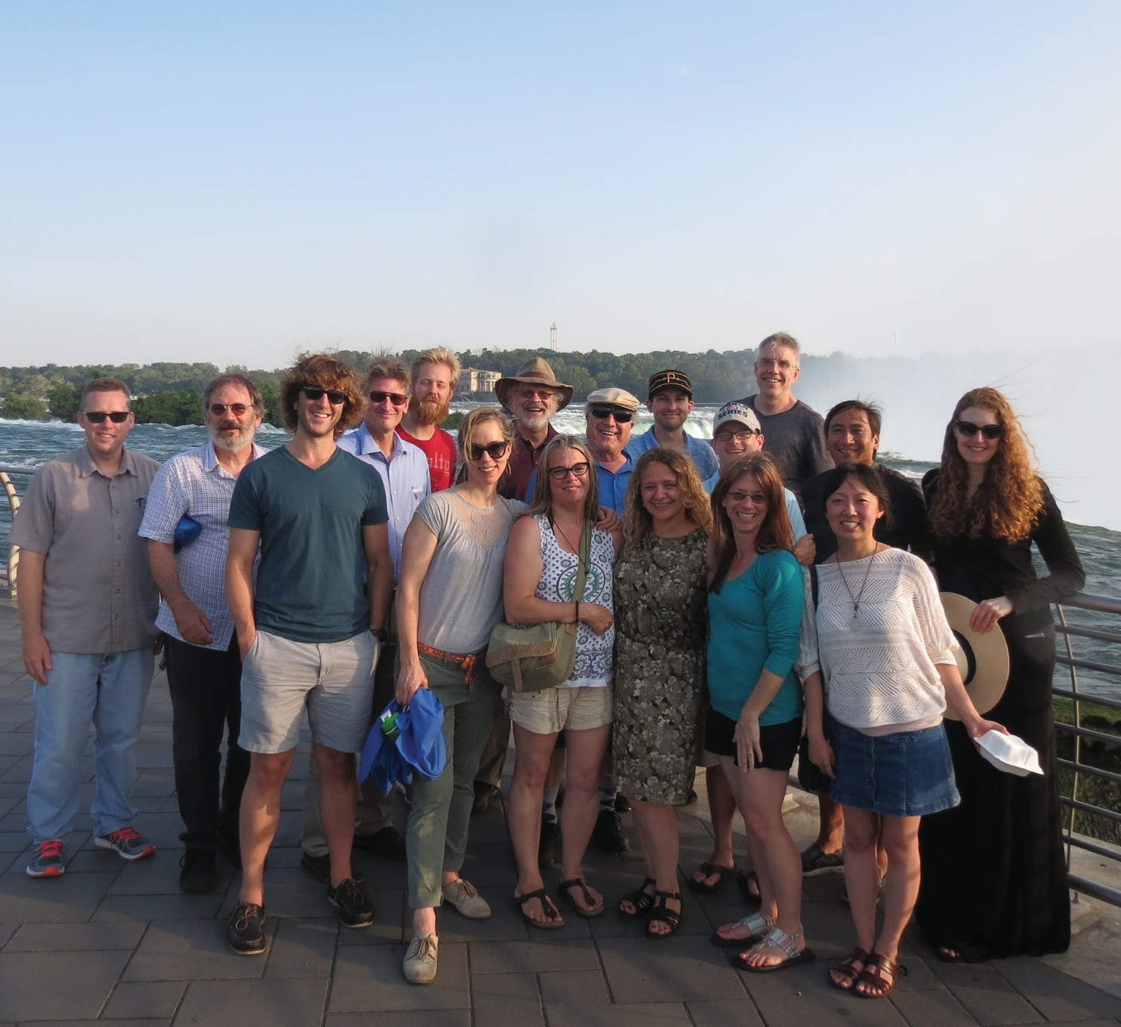

“Emmanuel Levinas on Morality, Justice and the Political”—an intense, week-long seminar focusing on the intersection be- tween morality and justice, between the face of the other, society at large, and the state— was the fifth in an internationally-known se- ries presented by Professor Richard Cohen.
The Levinas Summer Seminar Series frames all conversations around the think- ing of Emmanuel Levinas (1906-95), who is recognized as one of the most original and important philosophers of the 20th Century. Each year, the location of the seminar serves to inform the seminar topic.
This year’s seminar, held in Buffalo, in- cluded college and university faculty from across the country, representing a diverse array of disciplines: philosophy, English, psychology, religion and legal studies. Par- ticipants engaged in rigorous discussion, or, as Cohen notes, “renewed the essence of learning and education.”
The 2017 seminar was supported by a prestigious $70,000 grant from the National Endowment of the Humanities. UB Now featured an article on Professor Cohen in May: http://www.buffalo.edu/ubnow/ stories/2017/05/emmanuel-levinas- summer-seminar-2017.html

Recent Lectures and Symposiums

JEWS AND MELANCHOLIA INTERNATIONAL SYMPOSIUM A SUCCESS
An International Symposium on “Jews and Melancholia,” held in March 2017, was deemed a tremendous success. The two-
day symposium, organized by Professor Noam Pines, featured guest speakers considered to be world-renowned experts in their field. Review abstracts at: http://jewishthought.buffalo.edu/events/

JUSTICE SPEAKER SERIES HELD AT THE JEWISH COMMUNITY CENTER
In conjunction with the Bureau of Jewish Education, Adult Education Department,
a five-part lectures series was given by department faculty at the Jewish Community Center Benderson Family Building on the topic of “Justice – An
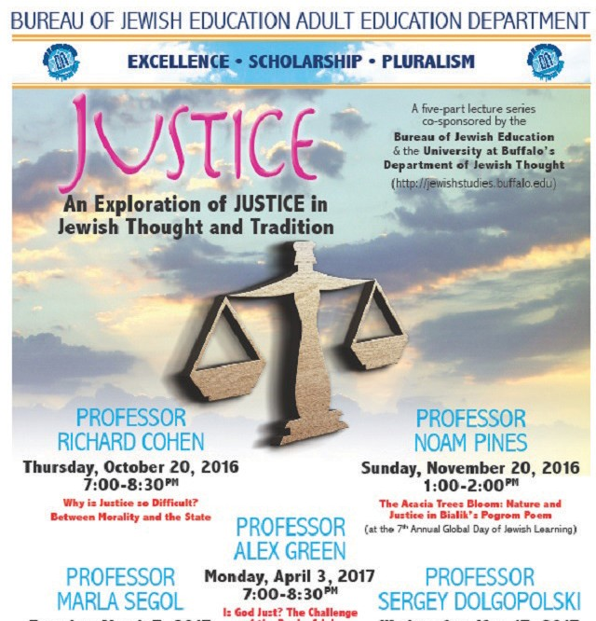Exploration of Justice in Jewish Thought and Tradition.” Discussion is underway for a 2017-18 lecture series.

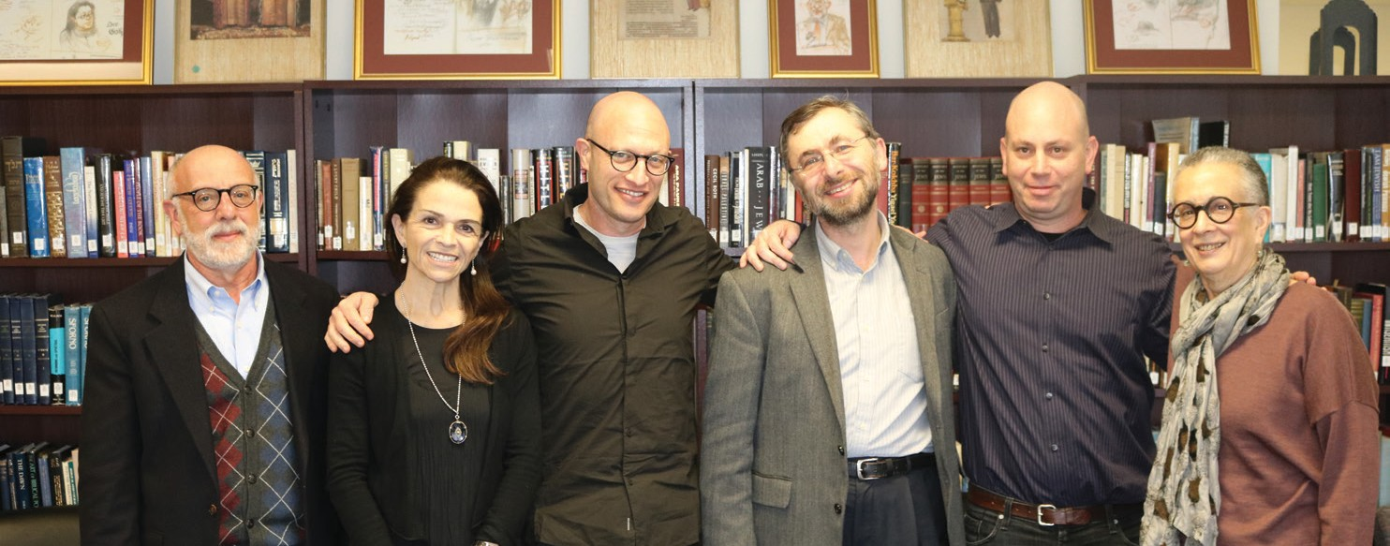

6 2017 Jewish Thought

ALUMNI AND FRIENDS

Alumni Updates
Logan Woodard (’17) and Joel Finkel- stein (’17) have been accepted into the Ezra Fellowship, which provides up to three years of exclusive training in pluralistic Jewish education, including immersive Jewish learning, seminars in experiential Jewish education and career coaching.
Logan is the current director of Jewish Student Life with Hillel at UB and has agreed to become their Ezra Fellow for the next two years, while Joel has agreed to
SPOTLIGHT
become Mizzou Hillel’s new Ezra Fellow and Program and Engagement Associate.
Nicole Caine (’17), featured in our 2016 newsletter, is beginning an MA in Public Administration (MPA), Public and Non- profit Management at Syracuse University.

We wish all of our alumni great success!

Follow us on Facebook for more alumni updates and student news. facebook.com/jewishthoughtbuffalo
2017 Fellowships, Scholarships and Awards
RUTH AND ISADORE BOB FELLOWSHIP FUND
Maryclaire Koch was selected to receive the 2017-18 Ruth and
Isadore Bob Fellowship to assist in the completion of her dissertation, “Identity as Phantasm: The Politics of Marc Chagall,” under advisement by Professor Noam Pines. This fellowship is made possible through a generous

Dr. Harold J. and Arlyne G. Levy

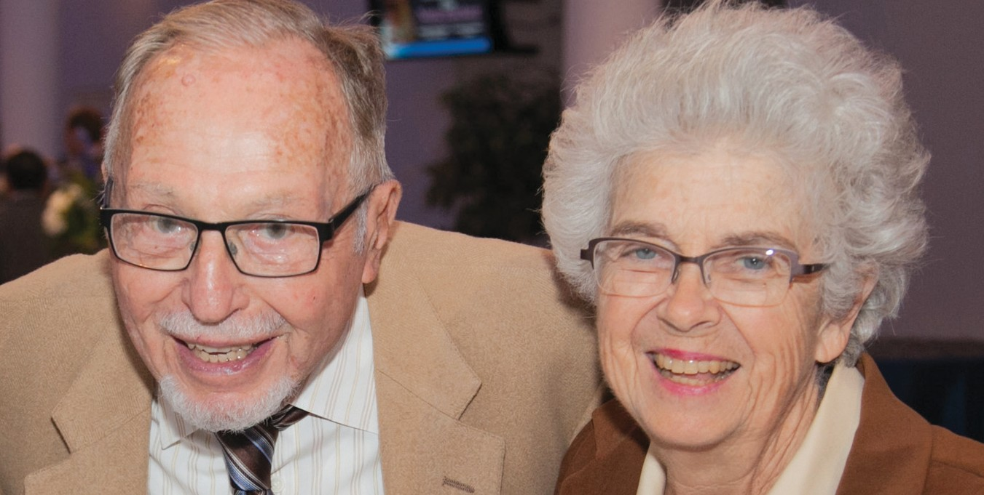
The notion of giving back through volunteerism and philanthropy is part of Harold and Arlyne’s philosophy. Their long-time support to the University is, as Harold described, “a return for the opportunities my education have provided.” The Levy family has a strong legacy at UB. Three generations of the family received medical degrees: Harold’s father in 1915, followed by Harold’s degree in 1946 and then, in 1986, Sanford, one of Harold and Arlyne’s sons, graduated.
Within the department, they established the Harold J. and Arlyne G. Levy Award for students who have demonstrated outstanding scholarship and commitment to the study of Jewish culture and heritage. This is just one part of their commitment to
helping students be enriched by the study of Jewish Thought. In 2016, they established a Lecture and Conference Fund in their name for the department to bring lectures to,
and host conferences at, UB for the benefit of the University and the greater community. Dr. Levy’s philanthropy also includes a bequest intention related to a special interest in the study of the psychological significance of Jewish ritual and tradition, a topic that as a psychiatrist and Jewish scholar is of interest to him.
The department’s mission to offer classes that encourage students within the department and from across UB to learn more about the rich history and importance of the Jewish tradition is key to the Levys’ personal mission. This, as Harold and Arlyne shared, helps to “instill a deeper sense of community where students can extend outward into the world and share their teachings.”
Harold noted, “We are proud to be able to help broaden society’s view of what the Jewish tradition is about.”
donation by Dr. Sharon Bob Young in honor of her parents, Ruth and Isadore Bob.

THE HAROLD J. AND ARLYNE G. LEVY AWARD IN JEWISH STUDIES
Jordan Einhorn, a major in political science with minors in Jewish studies, English and
education, was selected to receive
the 2017-18 Harold J. and Arlyne
G. Levy Award in Jewish Studies. You may remember Jordan from his profile in the 2016 newsletter. This award was established by the Levys to support students who have demonstrated outstanding scholarship and commitment to the study of Jewish culture and heritage.

THE IRVING M. AND MARILYN C. SHUMAN SCHOLARSHIP
Carly Fromm was selected to receive the 2017-18 Irving M. and Marilyn C. Shuman Scholarship. Carly begins her junior year this fall as a communications major with plans to attend law school after graduation. The Shumans established this scholarship
to support students who have demonstrated outstanding scholarship and commitment to the study of Jewish culture and heritage.

Jewish Thought 2017 7

8 2016 Jewish Thought

712 Clemens Hall Buffalo, New York 14260
Non Profit Org.
U.S. POSTAGE
PAID
Buffalo, NY Permit No. 311

Discover Their Research

jewishthought.buffalo.edu
JEWISH

THOUGHT

Newsletter 2017

